**Project Development Phase**

**Sprint-3 Dashboard**

|  |  |
| --- | --- |
| Date | 05 November 2022 |
| Team ID | PNT2022MID13550 |
| Project Name | Analysis for Hospital Health-care Data |

**Dashboard-1**

Overview of Data:

Age of patients with Case ID and filters of Departments and Severity of illness

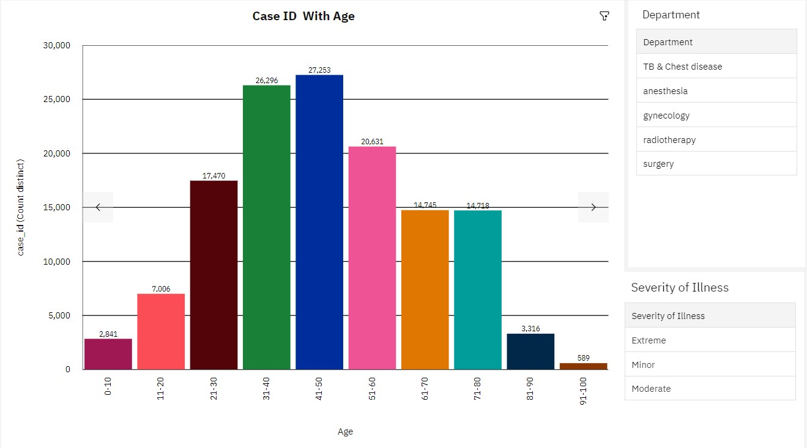

Severity of illness and Visitors in Hospitals

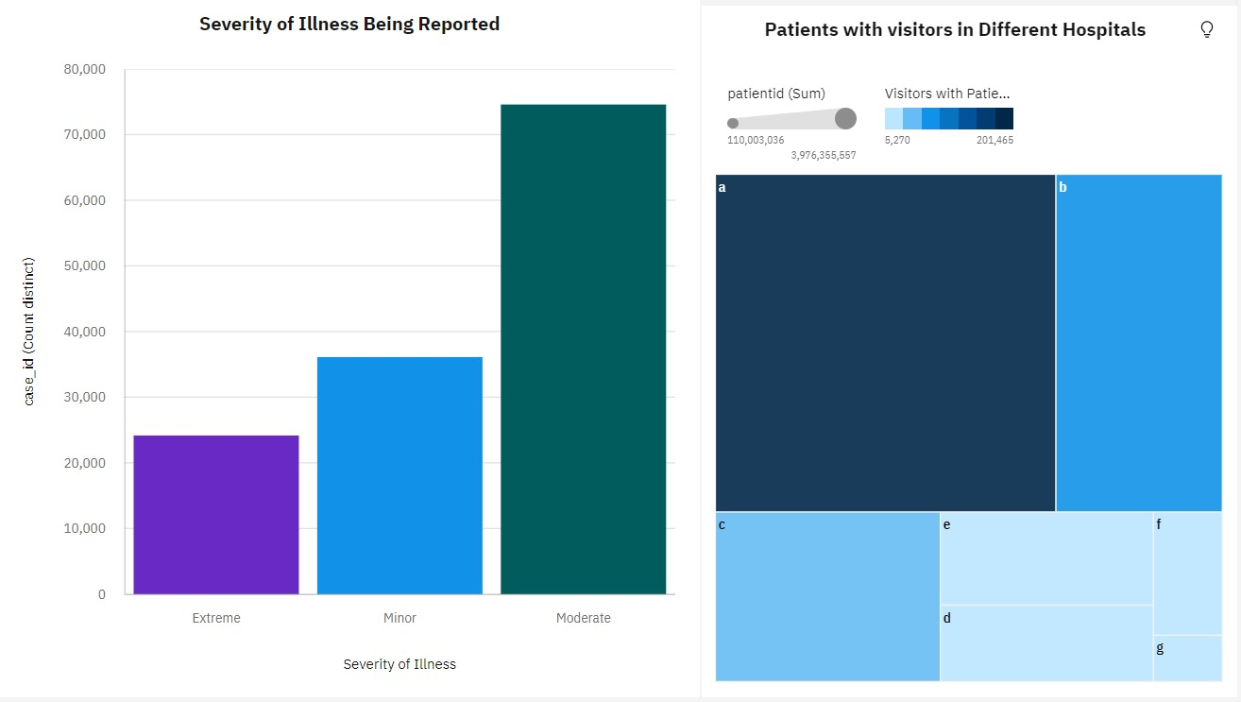

Ward type and Ward facility Analysis

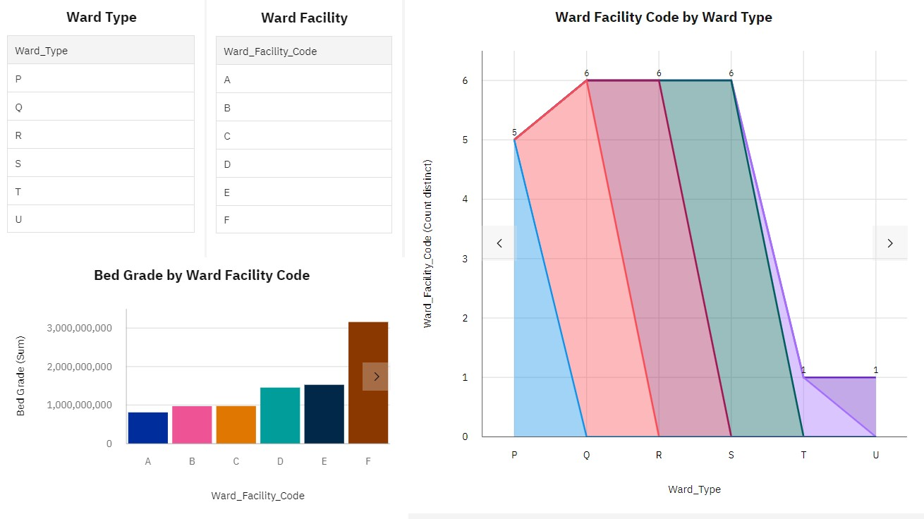

Dashboard-2:

To show number of patients

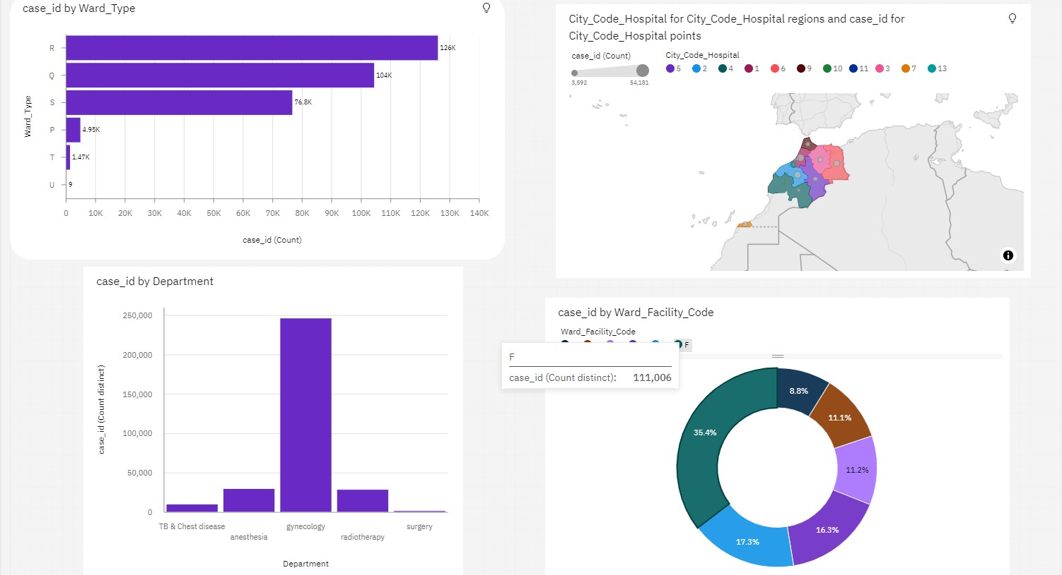

Dashboard with Hierarchy Bubble and Radial Visuals:

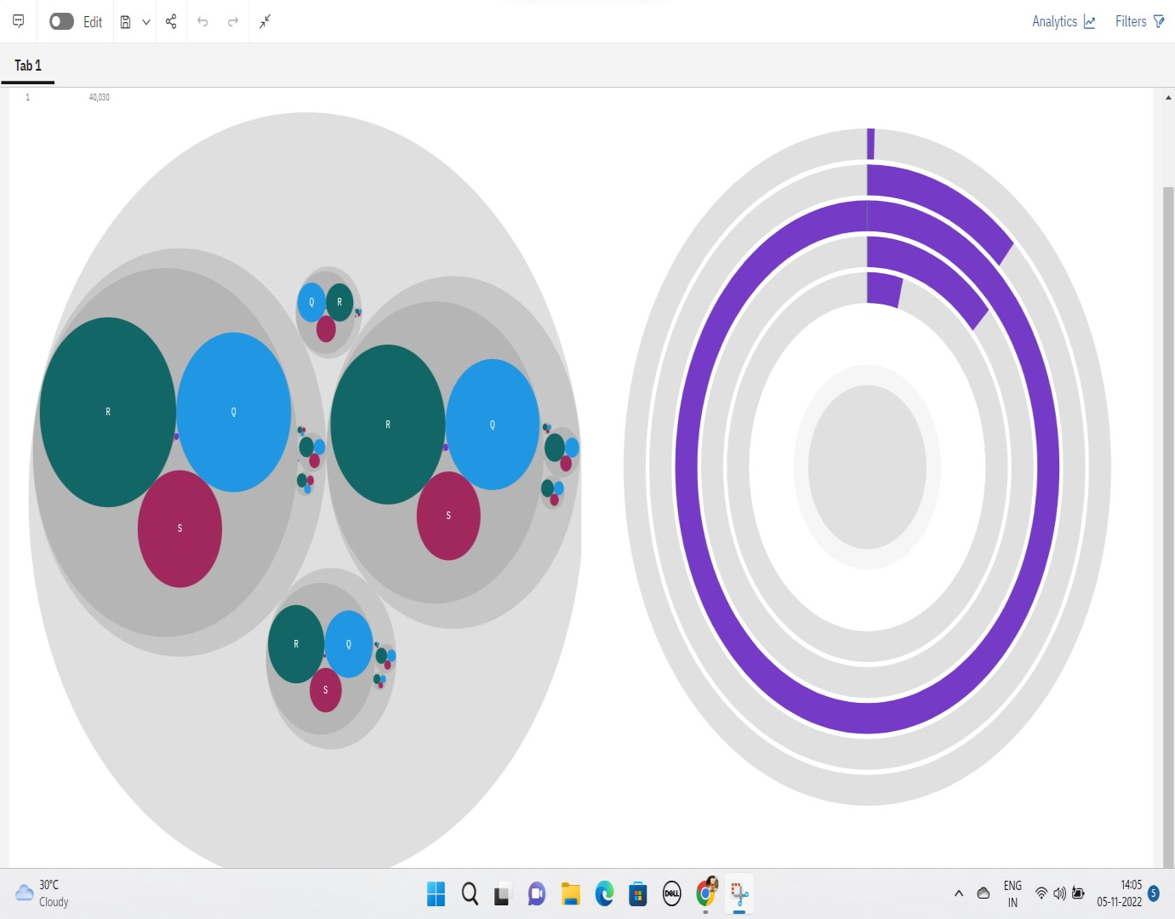

Dashboard Showing Pie, Stacked Bar, Waterfall And Pie Charts:

